

**Janardan Bhagat Shikshan Prasarak Sanstha’s**

**CHANGU KANA THAKUR**

**Arts, Commerce, Science College**

**New Panvel (W)**

**A PROJECT REPORT**

**ON:**

**“Brother’s Barber Shop Application”**

**SUBMITED TO:**

**“UNIVERSITY OF MUMBAI”**

**BY**

**Ms. Rohan Kiran Thakur**

**Under The Guidance Of**

**Prof. Mr. Navnit Bhoir**

**2019-2020**

**DEPARTMENT OF COMPUTER SCIENCE**

**CERTIFICATE**

**This is to certify that the project entailed**

**“Brother’s Barber Shop Application”**

**Is successfully completed by Mr. Rohan Kiran Thakur Roll No:64 Examination Number 2675 under the guidance of Prof. Navnit Bhoir during the academic period of 30th October,2019 to 10th March, 2020 per the syllabus , and the fulfilment for the completion of the B.Sc. Degree in the computer science of University of Mumbai. It is also to certify that this is original work of the candidate done during academic year 2019-2020.**

**Place:**

**Date:**

**Internal Examiner External Examiner**

**Principal Head of Department**

**BROTHER’S BARBER SHOP**

**CERTIFICATE**

This is to certify that **Mr. Rohan Kiran Thakur** has preparedtheWeb application entitled as “**Brother’s Barber Shop”** for **Vinod Thakur.** The Project is the result of his efforts & endeavors. The report is found worthy of acceptance as our web application.

He has prepared the project under Mineguidance & requirements. And fulfilled our Online Business Restaurant requirement. Completed and submitted the application on 14th Feb 2020.

**Place:** Uran

**Date:** 29/01/2020

**(Mr. Vinod Thakur )**

**OWNER**

**Acknowledgment**

It is indeed a matter of great pleasure and proud privilege to be able to present this project on "**Brothers’ Barber**" The completion of the project work is a milestone in student life and it execution 1S

inevitable in the hands of guide. I am highly indebted the projects guide.

**Prof. Mr. Navnit Bhoir** his invaluable guidance and appreciation for giving form and substance to this report. It is due to her enduring efforts; patience and enthusiasm, which has given a sense of direction and purposefulness to this project and ultimately made it a

Success.

I would like to tender our sincere thanks to the **H.O.D. Prof. Mrs. P. M. Jadhav** and all the teachers for their co-operation.

I would also like to express our deep regards and gratitude to the **Principal Mr.Barhate.**

I would Wish to thank the non - teaching staff and my friends who have helped

Really it is highly impossible to repay the dept of all the people who have me all the time in one way or the other directly or indirectly helped me for performing the project.

**Rohan Kiran Thakur**

**Index**

|  |  |  |  |
| --- | --- | --- | --- |
| **Sr.no** | **Title** | **Page no.** | **Remark** |
|  | **Project Synopsis and Introduction** | 3 |  |
|  | * Introduction * Objective Of Project * Abstract * Hardware Requirement * Software Requirement * Project Description * Advantages |  |  |
|  | **Design Phase** | 9 |  |
|  | * Event Table * Er Diagram * Use case * Sequence Diagram * Class Diagram |  |  |
|  | **System Coding** | 14 |  |
|  | **Result** | 38 |  |
|  | **Test case** | 58 |  |
|  | **Conclusion** | 59 |  |
|  | **Plagiarism Report** | 60 |  |
|  | **References** | 61 |  |

**SYNOPSIS**

**Introduction:**

Haircuts are the most marched for business category on the internet and many Haircuts now have a website. A well designed website will attract new customers to your Haircut, online reservations are increasing rapidly with so many consumers seeking out Haircuts via the web, and a well-designed website for a Haircut needs a few key elements that a customer looking to book would want to see. So we present you this system where an App for the users and An web application for the admin and Haircut completes the package of Haircut & bookings. The user can browse through number of Haircuts on the basis of cuisines and check for all their details and pictures uploaded by the Haircut, and the user can book it by selecting the s as well and other functionalities. The user can cancel and check his booking history or even review his previous experiences with the Haircut. While the admin is responsible to add a Haircut and check the booking history or user list. The Haircut user can check all the booking and enter check and check out status or even block a user from booking it again.

**Objectives of the Project:**

The system can be used in Haircuts and clubs for bookings. The system can also be used as software to promote various Haircuts.

**Abstract:**

* **Registration:** To access the system, user needs to register with his/her basic registration details.
* **Login:** After successful registration, user can login using their valid username and password.
* **Home:** On successful login, Bookings for today & count of bookings will be displayed.
* **Style:** Here, list of all the cuisines will be displayed.
* **Haircut Page:** Haircut details will be displayed where user can select a date & time for booking.
* **Map Direction:** On selection of map view the direction between the selected Haircut and your current location & rest with time & distance will be shown to the user.
* **View s:** User will book from the available s at the selected Haircut.
* **Bookings:** Here, user is shown current, previous and cancelled booking details.
* **Preview Bookings:** Once the admin updates as guest checked-out, the user will see a list of bookings that are yet to give his reviews.

**Requirements:**

* **Hardware Requirement:**
* i3 Processor Based Computer or higher
* Memory: 4 GB RAM
* Hard Drive: 50 GB
* Monitor
* Internet Connection
* **Software Requirement:**
* Windows 7 or higher
* Android Studio.
* SQLite.

**Project Description:**

A process model guides the order of project activities and represents the life cycle of a project. process model used for creating project is a spiral model

**Proposed system with Advantages:**

* Sometimes it happens that the s get booked soon during festive seasons therefore user can make advance booking using this system.
* It saves user’s time looking out for Haircuts.
* It saves business's resources and expenses.

**DESIGN PHASE**

**Event Table:-**

|  |  |  |  |  |  |  |
| --- | --- | --- | --- | --- | --- | --- |
| **No.** | **Events** | **Trigger** | **Source** | **Activity** | **Response** | **Destination** |
| **1.** | Users makes Appoinment | Checking Appointment  Availability | User | Look for the Appointment | Test granted or not details | User |
| **2.** | Registration of new User | User Registration | DC | Giving Registration | Users Registered | Handler |
| **4.** | Adding new Services | Service  Registration | DC | Adding new Service details | Service is adds | Handler |
| **5.** | Users wants a address of shop | Searching | User | Search for contact activity | Find Sucessful | Handler |

* **ER-Diagram:-**

**MESSAGE**

**APPOINTMENT BOOK**

**SERVICE**

**USERS**

* **Use case:-**

**Create New Account**

**Make Appointment**

**New User**

**Admin**

**Update Service Details**

**Take Appoint**

**Service Feedback**

**Log Out**

**Old Use**

**Maintains**

**Complaints**

* **Sequence diagram:-**

**Database**

**Appointment**

**Service**

**User**

**Does enquiry**

**Provide detail**

**Make an**

**Appointment**

**Store data of Order**

* **Class diagram:-**

**Service**

**Users**

**+Type**

**+Name**

**+Total Price**

**+Id**

**+Name**

**+Email id**

**+Mobile no**

address

**Add()**

**Add()**

**Insert()**

**Delete()**

**Appointment**

**+Id**

**+Name**

**+Time**

**+Date**

**+Mobile no**

**Add()**

**Update()**

**Delete()**

**System Coding**

**AndroidManifest.xml:**

<?xml version="1.0" encoding="utf-8"?>  
<manifest xmlns:android="http://schemas.android.com/apk/res/android"  
 package="com.example.brother_barbershop">  
 <application  
 android:allowBackup="true"  
 android:icon="@drawable/barberlogo"  
 android:label="@string/app_name"  
 android:roundIcon="@mipmap/ic_launcher_round"  
 android:supportsRtl="true"  
 android:theme="@style/AppTheme">  
 <activity android:name=".RegisterActivity"></activity>  
 <activity android:name=".MainActivity" />  
 <activity android:name=".OrdersActivity" />  
 <activity android:name=".ContactActivity" />  
 <activity android:name=".AdminActivity" />  
 <activity android:name=".AboutActivity" />  
 <activity android:name=".BarbersActivity" />  
 <activity android:name=".ServicesActivity" />  
 <activity android:name=".AppointmentActivity" />  
 <activity android:name=".LoginActivity">  
 <intent-filter>  
 <action android:name="android.intent.action.MAIN" />  
 <category android:name="android.intent.category.LAUNCHER" />  
 </intent-filter>  
 </activity>  
 </application>  
</manifest>

**Main.xml:**

<?xml version="1.0" encoding="utf-8"?>  
<menu xmlns:android="http://schemas.android.com/apk/res/android"  
 xmlns:app="http://schemas.android.com/apk/res-auto">  
 <item  
 android:title="Services"  
 android:id="@+id/item1"  
 android:orderInCategory="101"  
 app:showAsAction="never"  
 />  
 <item  
 android:title="Barbers"  
 android:id="@+id/item2"  
 android:orderInCategory="102"  
 app:showAsAction="never"  
 />  
 <item  
 android:title="About Us"  
 android:id="@+id/item3"  
 android:orderInCategory="103"  
 app:showAsAction="never"  
 />  
 <item  
 android:title="Admin"  
 android:id="@+id/item4"  
 android:orderInCategory="104"  
 app:showAsAction="always"  
 android:icon="@drawable/admin"  
 />  
 <item  
 android:title="Contact Us"  
 android:id="@+id/item5"  
 android:orderInCategory="105"  
 app:showAsAction="never"  
 />  
</menu>

**RegisterActivity.java:**

package com.example.brother_barbershop;  
  
import androidx.appcompat.app.AppCompatActivity;  
import android.content.Intent;  
import android.os.Bundle;  
import android.view.View;  
import android.widget.Button;  
import android.widget.EditText;  
import android.widget.TextView;  
import android.widget.Toast;  
  
public class RegisterActivity extends AppCompatActivity {  
 DatabaseHelper2 db;  
 EditText mTextUsername;  
 EditText mTextPassword;  
 EditText mTextCnfPassword;  
 Button mButtonRegister;  
 TextView mTextViewLogin;  
  
 @Override  
 protected void onCreate(Bundle savedInstanceState) {  
 super.onCreate(savedInstanceState);  
 setContentView(R.layout.*activity_register*);  
  
 db = new DatabaseHelper2(this);  
 mTextUsername = findViewById(R.id.*edittext_username*);  
 mTextPassword = findViewById(R.id.*edittext_password*);  
 mTextCnfPassword = findViewById(R.id.*edittext_cnf_password*);  
 mButtonRegister = findViewById(R.id.*button_register*);  
 mTextViewLogin = findViewById(R.id.*textview_login*);  
 mTextViewLogin.setOnClickListener(new View.OnClickListener() {  
 @Override  
 public void onClick(View view) {  
 Intent LoginIntent = new Intent(RegisterActivity.this,LoginActivity.class);  
 startActivity(LoginIntent);  
 }  
 });  
  
 mButtonRegister.setOnClickListener(new View.OnClickListener() {  
 @Override  
 public void onClick(View view) {  
 String user = mTextUsername.getText().toString().trim();  
 String pwd = mTextPassword.getText().toString().trim();  
 String cnf_pwd = mTextCnfPassword.getText().toString().trim();  
  
 if(pwd.equals(cnf_pwd)){  
 long val = db.addUser(user,pwd);  
 if(val > 0){  
 Toast.*makeText*(RegisterActivity.this,"You have registered",Toast.*LENGTH_SHORT*).show();  
 Intent moveToLogin = new Intent(RegisterActivity.this,LoginActivity.class);  
 startActivity(moveToLogin);  
 }  
 else{  
 Toast.*makeText*(RegisterActivity.this,"Registeration Error",Toast.*LENGTH_SHORT*).show();  
 }  
  
 }  
 else{  
 Toast.*makeText*(RegisterActivity.this,"Password is not matching",Toast.*LENGTH_SHORT*).show();  
 }  
 }  
 });  
  
  
 }  
}

**ServicesActivity.java:**

package com.example.brother_barbershop;  
  
import androidx.appcompat.app.AppCompatActivity;  
import android.os.Bundle;  
import android.view.View;  
import android.widget.ExpandableListAdapter;  
import android.widget.ExpandableListView;  
import android.widget.Toast;  
import java.util.ArrayList;  
import java.util.HashMap;  
import java.util.List;  
  
public class ServicesActivity extends AppCompatActivity {  
 ExpandableListView expandableListView;  
 ExpandableListAdapter expandableListAdapter;  
 List<String> expandableListTitle;  
 HashMap<String, List<String>> expandableListDetail;  
 @Override  
 protected void onCreate(Bundle savedInstanceState) {  
 super.onCreate(savedInstanceState);  
 setContentView(R.layout.*activity_services*);  
  
 expandableListView = findViewById(R.id.*expandableListView*);  
 expandableListDetail = ExpandableListDataPump.*getData*();  
 expandableListTitle = new ArrayList<String>(expandableListDetail.keySet());  
 expandableListAdapter = new CustomExpandableListAdapter(this, expandableListTitle, expandableListDetail);  
 expandableListView.setAdapter(expandableListAdapter);  
 expandableListView.setOnGroupExpandListener(new ExpandableListView.OnGroupExpandListener() {  
  
 @Override  
 public void onGroupExpand(int groupPosition) {  
 Toast.*makeText*(getApplicationContext(),  
 expandableListTitle.get(groupPosition) + " List Expanded.",  
 Toast.*LENGTH_SHORT*).show();  
 }  
 });  
  
 expandableListView.setOnGroupCollapseListener(new ExpandableListView.OnGroupCollapseListener() {  
  
 @Override  
 public void onGroupCollapse(int groupPosition) {  
 Toast.*makeText*(getApplicationContext(),  
 expandableListTitle.get(groupPosition) + " List Collapsed.",  
 Toast.*LENGTH_SHORT*).show();  
  
 }  
 });  
  
 expandableListView.setOnChildClickListener(new ExpandableListView.OnChildClickListener() {  
 @Override  
 public boolean onChildClick(ExpandableListView parent, View v,  
 int groupPosition, int childPosition, long id) {  
 Toast.*makeText*(  
 getApplicationContext(),  
 expandableListTitle.get(groupPosition)  
 + " -> "  
 + expandableListDetail.get(  
 expandableListTitle.get(groupPosition)).get(  
 childPosition), Toast.*LENGTH_SHORT* ).show();  
 return false;  
 }  
 });  
  
 }  
}

**AppointmentActivity.java:**

package com.example.brother_barbershop;

import androidx.appcompat.app.AppCompatActivity;  
import android.os.Bundle;  
import android.view.View;  
import android.widget.Button;  
import android.widget.EditText;  
import android.widget.Toast;  
  
public class AppointmentActivity extends AppCompatActivity {  
 private static final String *TAG* = "AppintmentActivity";  
  
 private DatabaseHelper mDatabaseHelper;  
 private Button book_btn;  
  
 private EditText names,emails,phones,dates,times;  
  
  
 @Override  
 protected void onCreate(Bundle savedInstanceState) {  
 super.onCreate(savedInstanceState);  
 setContentView(R.layout.*activity_appointment*);  
  
 book_btn = findViewById(R.id.*bookbtn*);  
 names = findViewById(R.id.*txt_name*);  
 emails = findViewById(R.id.*txt_email*);  
 phones = findViewById(R.id.*txt_phone*);  
 dates = findViewById(R.id.*txt_date*);  
 times = findViewById(R.id.*txt_time*);  
  
 mDatabaseHelper = new DatabaseHelper(this);  
  
 book_btn.setOnClickListener(new View.OnClickListener() {  
  
 @Override  
 public void onClick(View v) {  
 String newEntry1 = names.getText().toString();  
 String newEntry2 = emails.getText().toString();  
 String newEntry3 = phones.getText().toString();  
 String newEntry4 = dates.getText().toString();  
 String newEntry5 = times.getText().toString();  
  
 if ((names.length() != 0)&&(emails.length() != 0)&&(phones.length() == 10)&&(dates.length() != 0)&&(times.length() != 0)) {  
 AddData(newEntry1,newEntry2,newEntry3,newEntry4,newEntry5);  
 names.setText("");  
 emails.setText("");  
 phones.setText("");  
 dates.setText("");  
 times.setText("");  
 }  
 else {  
 toastMessage("You must put something in the text field!");  
 toastMessage("You must put 10 digit phone number!");  
 }  
 }  
 });  
 }  
  
 public void AddData(String newEntry1,String newEntry2,String newEntry3,String newEntry4,String newEntry5) {  
 boolean insertData = mDatabaseHelper.addData(newEntry1,newEntry2,newEntry3,newEntry4,newEntry5);  
 if (insertData) {  
 toastMessage("Data Successfully Inserted!");  
 }  
 else {  
 toastMessage("Something went wrong");  
 }  
 }  
 private void toastMessage(String message){  
 Toast.*makeText*(this,message, Toast.*LENGTH_SHORT*).show();  
 }  
}

**MainActivity.java:**

package com.example.brother_barbershop;  
  
import androidx.appcompat.app.AppCompatActivity;  
import android.content.Intent;  
import android.media.MediaPlayer;  
import android.os.Bundle;  
import android.view.MenuInflater;  
import android.view.View;  
import android.widget.Button;  
import android.view.Menu;  
import android.view.MenuItem;  
  
public class MainActivity extends AppCompatActivity {  
MediaPlayer mediaPlayer;  
 @Override  
 protected void onCreate(Bundle savedInstanceState) {  
 super.onCreate(savedInstanceState);  
 setContentView(R.layout.*activity_main*);  
  
 mediaPlayer = MediaPlayer.*create*(MainActivity.this,R.raw.*music*);  
 mediaPlayer.start();  
  
 Button b1 = findViewById(R.id.*btn1*);  
 b1.setOnClickListener(new View.OnClickListener() {  
 @Override  
 public void onClick(View view) {  
 Intent intent = new Intent(MainActivity.this, AppointmentActivity.class);  
 startActivity(intent);  
 }  
 });  
 }  
  
 @Override  
 public boolean onCreateOptionsMenu(Menu menu) {  
 MenuInflater inflater = getMenuInflater();  
 inflater.inflate(R.menu.*main*, menu);  
 return super.onCreateOptionsMenu(menu);  
 }  
  
 @Override  
 public boolean onOptionsItemSelected(MenuItem item) {  
 switch (item.getItemId()) {  
 case R.id.*item1*:  
 Intent int1 = new Intent(this, ServicesActivity.class);  
 startActivity(int1);  
 break;  
 case R.id.*item2*:  
 Intent int2 = new Intent(this, BarbersActivity.class);  
 startActivity(int2);  
 break;  
 case R.id.*item3*:  
 Intent int3 = new Intent(this, AboutActivity.class);  
 startActivity(int3);  
 break;  
 case R.id.*item4*:  
 Intent int4 = new Intent(this, AdminActivity.class);  
 startActivity(int4);  
 break;  
 case R.id.*item5*:  
 Intent int5 = new Intent(this, ContactActivity.class);  
 startActivity(int5);  
 break;  
 case R.id.*end*:  
 break;  
 }  
 return super.onOptionsItemSelected(item);  
  
 }  
  
}

**OrdersActivity.java:**

package com.example.brother_barbershop;  
  
import androidx.appcompat.app.AppCompatActivity;  
import android.os.Bundle;  
import android.database.Cursor;  
import android.util.Log;  
import android.view.View;  
import android.widget.ArrayAdapter;  
import android.widget.Button;  
import android.widget.EditText;  
import android.widget.ListAdapter;  
import android.widget.ListView;  
import android.widget.Toast;  
import java.util.ArrayList;  
  
public class OrdersActivity extends AppCompatActivity {  
  
 private static final String *TAG* = "OrdersActivity";  
 DatabaseHelper mDatabaseHelper;  
 private ListView mListView;  
 public Button btnDelete;  
 public EditText editTextId;  
  
 @Override  
 protected void onCreate(Bundle savedInstanceState) {  
 super.onCreate(savedInstanceState);  
 setContentView(R.layout.*activity_orders*);  
 mListView = findViewById(R.id.*listView*);  
 mDatabaseHelper = new DatabaseHelper(this);  
 btnDelete = findViewById(R.id.*del_btn*);  
 editTextId = findViewById(R.id.*editTId*);  
 populateListView();  
 DeleteData();  
 }

private void populateListView() {  
 Log.*d*(*TAG*, "populateListView: Displaying data in the ListView.");  
 Cursor data = mDatabaseHelper.getData();  
 ArrayList<String> listData = new ArrayList<>();  
 while(data.moveToNext()){  
 listData.add(data.getString(0));  
 listData.add(data.getString(1));  
 listData.add(data.getString(2));  
 listData.add(data.getString(3));  
 listData.add(data.getString(4));  
 listData.add(data.getString(5));  
 }  
 ListAdapter adapter = new ArrayAdapter<>(this, android.R.layout.*simple_list_item_1*, listData);  
 mListView.setAdapter(adapter);  
 }  
  
 public void DeleteData() {  
 btnDelete.setOnClickListener(  
 new View.OnClickListener() {  
 @Override  
 public void onClick(View v) {  
 Integer deletedRows = mDatabaseHelper.deleteData(editTextId.getText().toString());  
 if(deletedRows > 0)  
 Toast.*makeText*(OrdersActivity.this,"Data Deleted", Toast.*LENGTH_LONG*).show();  
 else  
 Toast.*makeText*(OrdersActivity.this,"Data not Deleted",Toast.*LENGTH_LONG*).show();  
 }  
 }  
 );  
 }  
 }

**ContactActivity.java:**

package com.example.brother_barbershop;  
  
import androidx.appcompat.app.AppCompatActivity;  
  
import android.content.Intent;  
import android.net.Uri;  
import android.os.Bundle;  
import android.view.View;  
import android.widget.Button;  
  
public class ContactActivity extends AppCompatActivity {  
  
 @Override  
 protected void onCreate(Bundle savedInstanceState) {  
 super.onCreate(savedInstanceState);  
 setContentView(R.layout.*activity_contact*);  
  
 Button b1 = findViewById(R.id.*btn1*);  
 b1.setOnClickListener(new View.OnClickListener() {  
 @Override  
 public void onClick(View view) {  
 String cl = "http://www.gmail.com";  
 Intent intent = new Intent(Intent.*ACTION_VIEW*, Uri.*parse*(cl));  
 startActivity(intent);  
 }  
 });  
  
 Button b2 = findViewById(R.id.*btn2*);  
 b2.setOnClickListener(new View.OnClickListener() {  
 @Override  
 public void onClick(View view) {  
 String ml = "http://www.facebook.com";  
 Intent intent = new Intent(Intent.*ACTION_VIEW*, Uri.*parse*(ml));  
 startActivity(intent);  
 }  
 });  
 Button b3 = findViewById(R.id.*btn3*);  
 b3.setOnClickListener(new View.OnClickListener() {  
 @Override  
 public void onClick(View view) {  
 String cl = "https://in.linkedin.com/";  
 Intent intent = new Intent(Intent.*ACTION_VIEW*, Uri.*parse*(cl));  
 startActivity(intent);  
 }  
 });  
  
 Button b4 = findViewById(R.id.*btn4*);  
 b4.setOnClickListener(new View.OnClickListener() {  
 @Override  
 public void onClick(View view) {  
 String ml = "https://in.pinterest.com/";  
 Intent intent = new Intent(Intent.*ACTION_VIEW*, Uri.*parse*(ml));  
 startActivity(intent);  
 }  
 });  
 Button b5 = findViewById(R.id.*btn5*);  
 b5.setOnClickListener(new View.OnClickListener() {  
 @Override  
 public void onClick(View view) {  
 String cl = "https://twitter.com/";  
 Intent intent = new Intent(Intent.*ACTION_VIEW*, Uri.*parse*(cl));  
 startActivity(intent);  
 }  
 });  
  
  
 }  
}

**AdminActivity.java:**

package com.example.brother_barbershop;  
  
import androidx.appcompat.app.AppCompatActivity;  
import android.content.Intent;  
import android.os.Bundle;  
import android.view.View;  
import android.widget.Button;  
import android.widget.EditText;  
import android.widget.Toast;  
  
  
  
public class AdminActivity extends AppCompatActivity {  
 @Override  
 protected void onCreate(Bundle savedInstanceState) {  
 super.onCreate(savedInstanceState);  
 setContentView(R.layout.*activity_admin*);  
  
 Button login = findViewById(R.id.*loginbtn*);  
 Button home = findViewById(R.id.*homebtn*);  
  
 login.setOnClickListener(new View.OnClickListener() {  
 @Override  
 public void onClick(View view) {  
 EditText un = findViewById(R.id.*username*);  
 EditText pw = findViewById(R.id.*password*);  
 String s1 = un.getText().toString();  
 String s2 = pw.getText().toString();  
  
 if(s1.equals("admin")&& s2.equals("admin")) {  
 Toast.*makeText*(AdminActivity.this,"Correct Password ", Toast.*LENGTH_SHORT*).show();  
 startActivity(new Intent(AdminActivity.this,OrdersActivity.class));  
 }  
 else {  
 un.setText("");  
 pw.setText("");  
 Toast.*makeText*(AdminActivity.this,"Wrong Password ", Toast.*LENGTH_SHORT*).show();  
 }  
  
 }  
 });  
  
 home.setOnClickListener(new View.OnClickListener() {  
 @Override  
 public void onClick(View view) {  
 Intent int2 = new Intent(AdminActivity.this,MainActivity.class);  
 startActivity(int2);  
 }  
 });  
 }  
}

**LoginActivity.java:**

package com.example.brother_barbershop;  
  
import androidx.appcompat.app.AppCompatActivity;  
import android.content.Intent;  
import android.os.Bundle;  
import android.view.View;  
import android.widget.Button;  
import android.widget.EditText;  
import android.widget.TextView;  
import android.widget.Toast;  
  
public class LoginActivity extends AppCompatActivity {  
 EditText mTextUsername;  
 EditText mTextPassword;  
 Button mButtonLogin;  
 TextView mTextViewRegister;  
 DatabaseHelper2 db;  
  
 @Override  
 protected void onCreate(Bundle savedInstanceState) {  
 super.onCreate(savedInstanceState);  
 setContentView(R.layout.*activity_login*);  
  
 db = new DatabaseHelper2(this);  
 mTextUsername = findViewById(R.id.*edittext_username*);  
 mTextPassword = findViewById(R.id.*edittext_password*);  
 mButtonLogin = findViewById(R.id.*button_login*);  
 mTextViewRegister = findViewById(R.id.*textview_register*);  
 mTextViewRegister.setOnClickListener(new View.OnClickListener() {  
 @Override  
 public void onClick(View view) {  
 Intent registerIntent = new Intent(LoginActivity.this,RegisterActivity.class);  
 startActivity(registerIntent);  
 }  
 });  
 mButtonLogin.setOnClickListener(new View.OnClickListener() {  
 @Override  
 public void onClick(View view) {  
 String user = mTextUsername.getText().toString().trim();  
 String pwd = mTextPassword.getText().toString().trim();  
 Boolean res = db.checkUser(user, pwd);  
 if(res == true)  
 {  
 Intent HomePage = new Intent(LoginActivity.this,MainActivity.class);  
 startActivity(HomePage);  
 Toast.*makeText*(LoginActivity.this,"Login Sucessfully",Toast.*LENGTH_LONG*).show();  
 }  
 else  
 {  
 Toast.*makeText*(LoginActivity.this,"Login Error",Toast.*LENGTH_SHORT*).show();  
 }  
 }  
 });  
 }  
  
}

**DatabaseHelper.java:**

package com.example.brother_barbershop;  
  
import android.content.ContentValues;  
import android.content.Context;  
import android.database.Cursor;  
import android.database.sqlite.SQLiteDatabase;  
import android.database.sqlite.SQLiteOpenHelper;  
  
public class DatabaseHelper2 extends SQLiteOpenHelper{  
 public static final String *DATABASE_NAME* ="register.db";  
 public static final String *TABLE_NAME* ="registeruser";  
 public static final String *COL_1* ="ID";  
 public static final String *COL_2* ="username";  
 public static final String *COL_3* ="password";  
  
 public DatabaseHelper2(Context context) {  
 super(context, *DATABASE_NAME*, null, 1);  
 }  
  
 @Override  
 public void onCreate(SQLiteDatabase sqLiteDatabase) {  
 sqLiteDatabase.execSQL("CREATE TABLE registeruser (ID INTEGER PRIMARY KEY AUTOINCREMENT, username TEXT, password TEXT)");  
 }  
  
 @Override  
 public void onUpgrade(SQLiteDatabase sqLiteDatabase, int i, int i1) {  
 sqLiteDatabase.execSQL(" DROP TABLE IF EXISTS " + *TABLE_NAME*);  
 onCreate(sqLiteDatabase);  
 }  
  
 public long addUser(String user, String password){  
 SQLiteDatabase db = this.getWritableDatabase();  
 ContentValues contentValues = new ContentValues();  
 contentValues.put("username",user);  
 contentValues.put("password",password);  
 long res = db.insert("registeruser",null,contentValues);  
 db.close();  
 return res;  
 }  
  
 public boolean checkUser(String username, String password){  
 String[] columns = { *COL_1* };  
 SQLiteDatabase db = getReadableDatabase();  
 String selection = *COL_2* + "=?" + " and " + *COL_3* + "=?";  
 String[] selectionArgs = { username, password };  
 Cursor cursor = db.query(*TABLE_NAME*,columns,selection,selectionArgs,null,null,null);  
 int count = cursor.getCount();  
 cursor.close();  
 db.close();  
  
 if(count>0)  
 return true;  
 else  
 return false;  
 }  
}

**DatabaseHelper2.java:**

package com.example.brother_barbershop;  
  
import android.content.ContentValues;  
import android.content.Context;  
import android.database.Cursor;  
import android.database.sqlite.SQLiteDatabase;  
import android.database.sqlite.SQLiteOpenHelper;  
import android.util.Log;  
  
  
public class DatabaseHelper extends SQLiteOpenHelper {  
  
 private static final String *TAG* = "DatabaseHelper";  
 private static final String *TABLE_NAME* = "order_table";  
 private static final String *COL1* = "ID";  
 private static final String *COL2* = "name";  
 private static final String *COL3* = "email";  
 private static final String *COL4* = "phone";  
 private static final String *COL5* = "date";  
 private static final String *COL6* = "time";  
  
  
 public DatabaseHelper(Context context) {  
 super(context, *TABLE_NAME*, null, 1);  
 }  
  
 @Override  
 public void onCreate(SQLiteDatabase db) {  
 String createTable = "CREATE TABLE " + *TABLE_NAME* + " (ID INTEGER PRIMARY KEY AUTOINCREMENT, " +  
 *COL2* +" TEXT,"+*COL3* +" TEXT,"+*COL4* +" TEXT,"+*COL5* +" TEXT,"+*COL6* +" TEXT)";  
 db.execSQL(createTable);  
 }  
  
 @Override  
 public void onUpgrade(SQLiteDatabase db, int i, int i1) {  
 db.execSQL("DROP IF TABLE EXISTS " + *TABLE_NAME*);  
 onCreate(db);  
 }  
  
 public Integer deleteData (String id) {  
 SQLiteDatabase db = this.getWritableDatabase();  
 return db.delete(*TABLE_NAME*, "ID = ?",new String[] {id});  
 }  
  
 public boolean addData(String item1,String item2,String item3,String item4,String item5) {  
 SQLiteDatabase db = this.getWritableDatabase();  
 ContentValues contentValues = new ContentValues();  
 contentValues.put(*COL2*, item1);  
 contentValues.put(*COL3*, item2);  
 contentValues.put(*COL4*, item3);  
 contentValues.put(*COL5*, item4);  
 contentValues.put(*COL6*, item5);  
  
 Log.*d*(*TAG*, "addData: Adding " + item1+item2+item3+item4+item5 + " to " + *TABLE_NAME*);  
  
 long result = db.insert(*TABLE_NAME*, null, contentValues);  
  
 //if date as inserted incorrectly it will return -1  
 if (result == -1) {  
 return false;  
 } else {  
 return true;  
 }  
 }  
  
 public Cursor getData(){  
 SQLiteDatabase db = this.getWritableDatabase();  
 String query = "SELECT * FROM " + *TABLE_NAME*;  
 Cursor data = db.rawQuery(query, null);  
 return data;  
 }  
  
 public Cursor getItemID(String name,String email,String phone,String date,String time){  
 SQLiteDatabase db = this.getWritableDatabase();  
 String query = "SELECT " + *COL1* + " FROM " + *TABLE_NAME* +  
 " WHERE " + *COL2* + " = '" + name + "'"+ *COL3* + " = '" + email + "'"+ *COL4* + " = '" + phone + "'"+ *COL5* + " = '" + date + "'"+ *COL6* + " = '" + time + "'";  
 Cursor data = db.rawQuery(query, null);  
 return data;  
 }  
  
}

**OUTPUT**

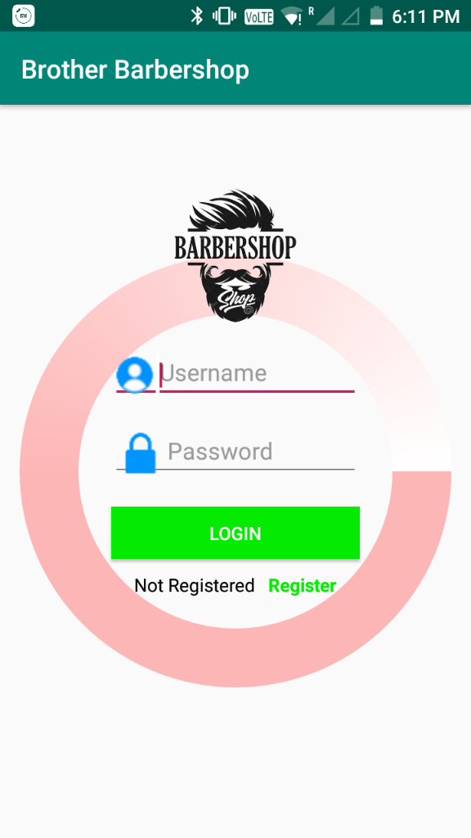 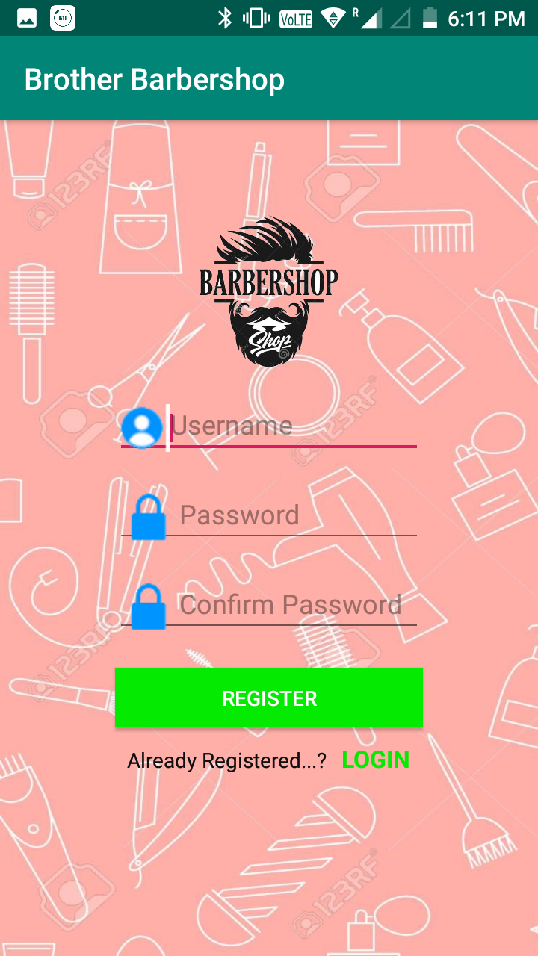

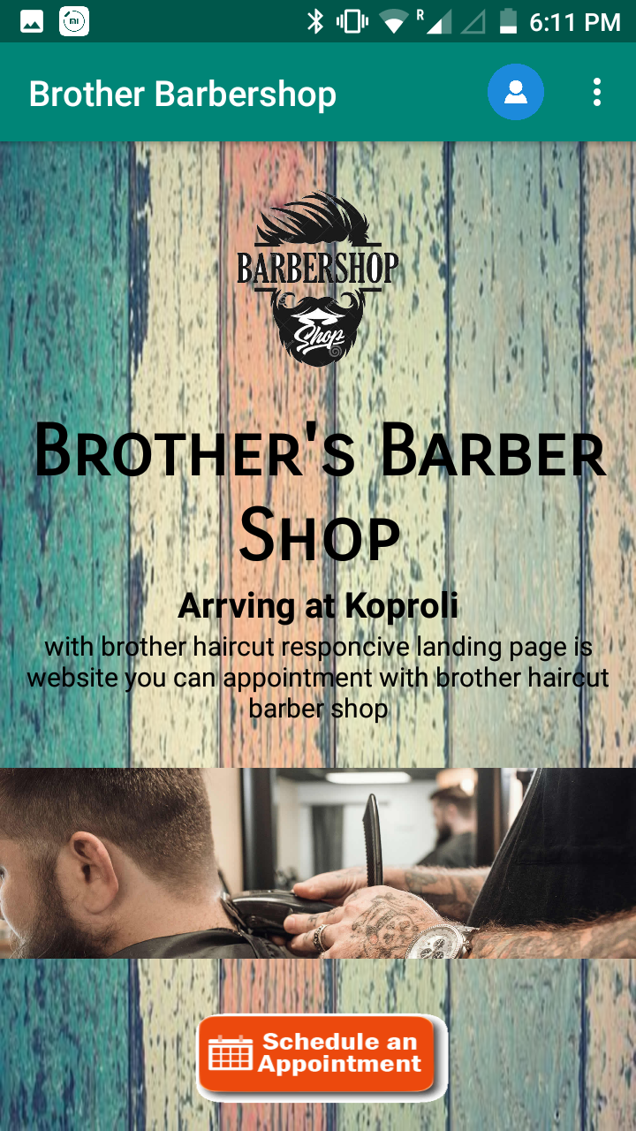 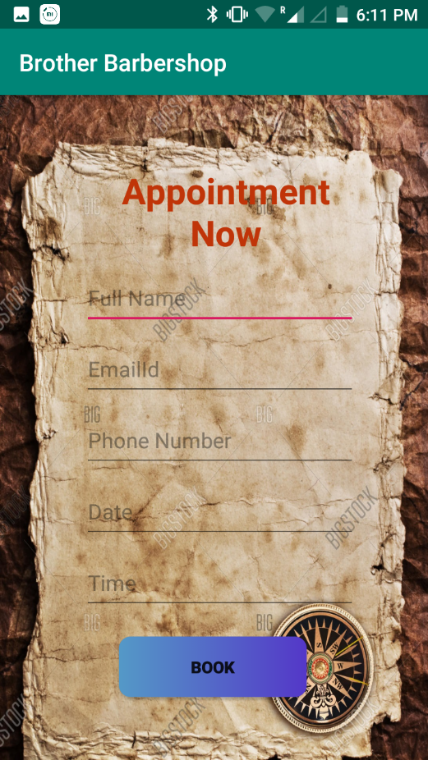

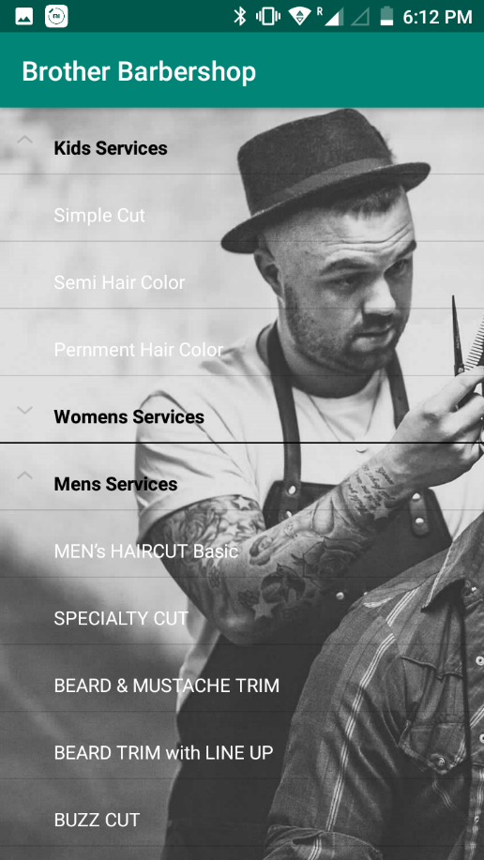 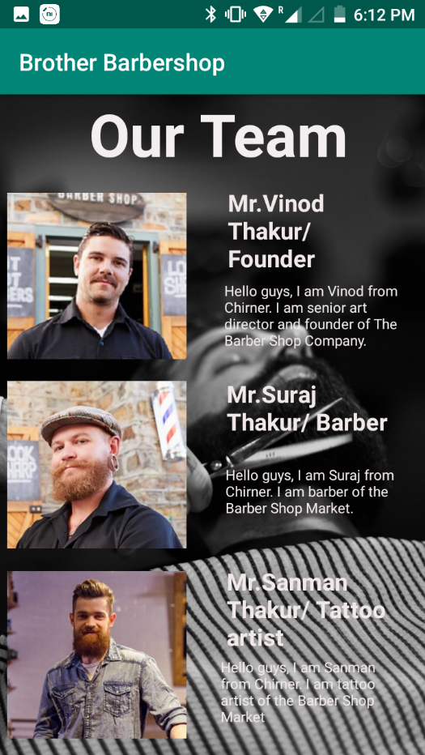

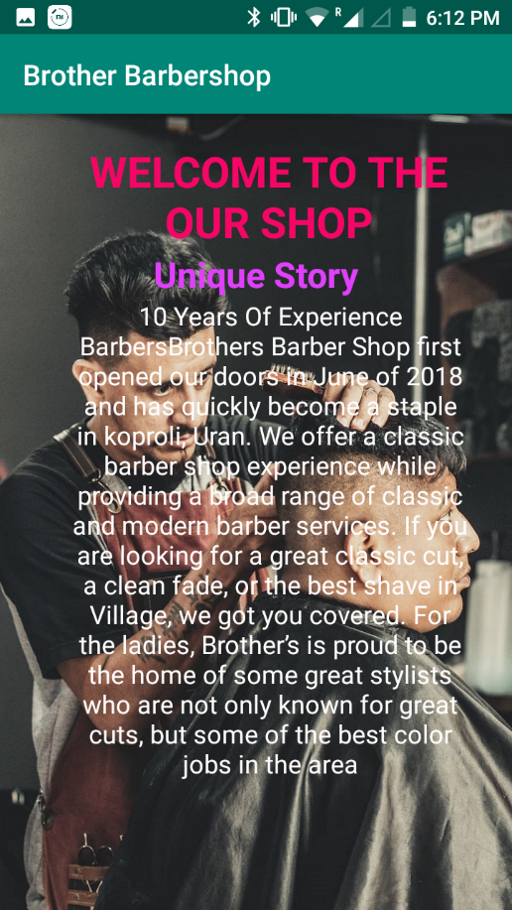 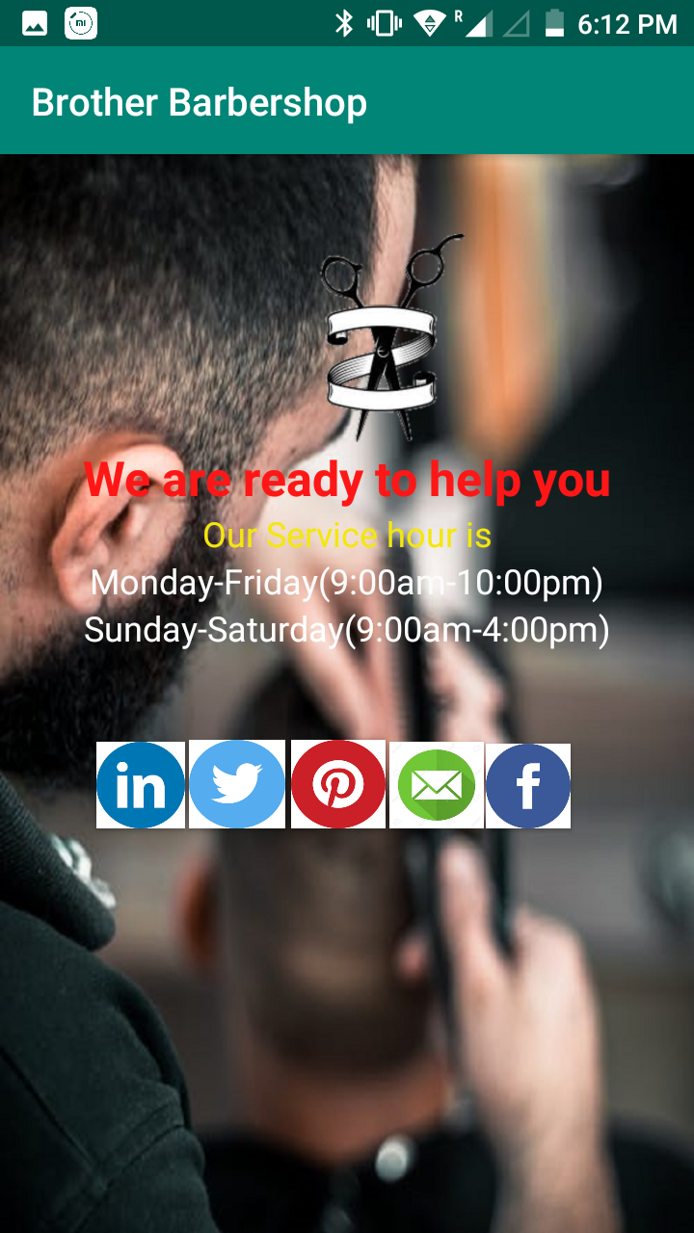

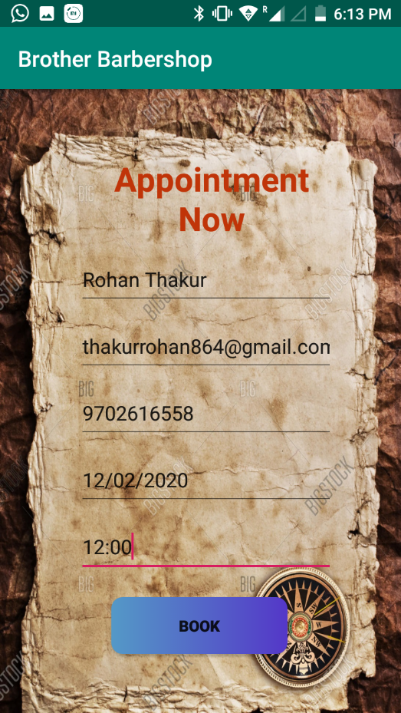 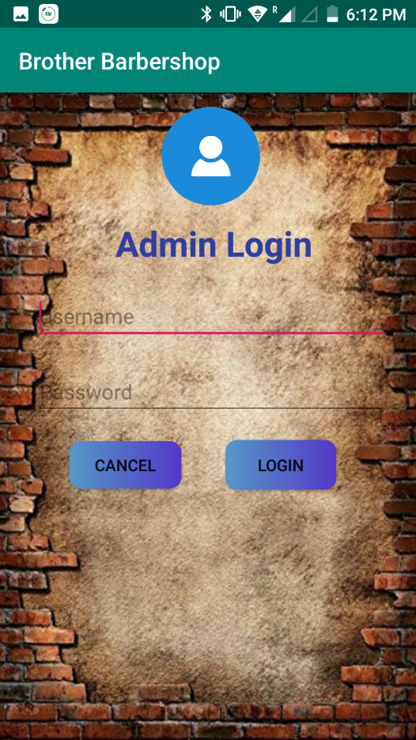

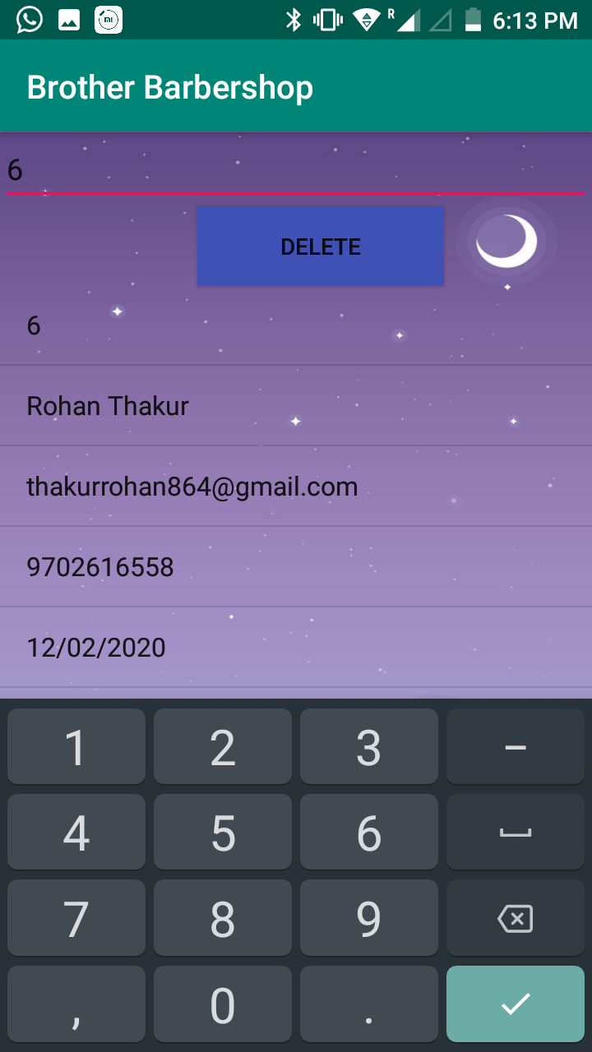 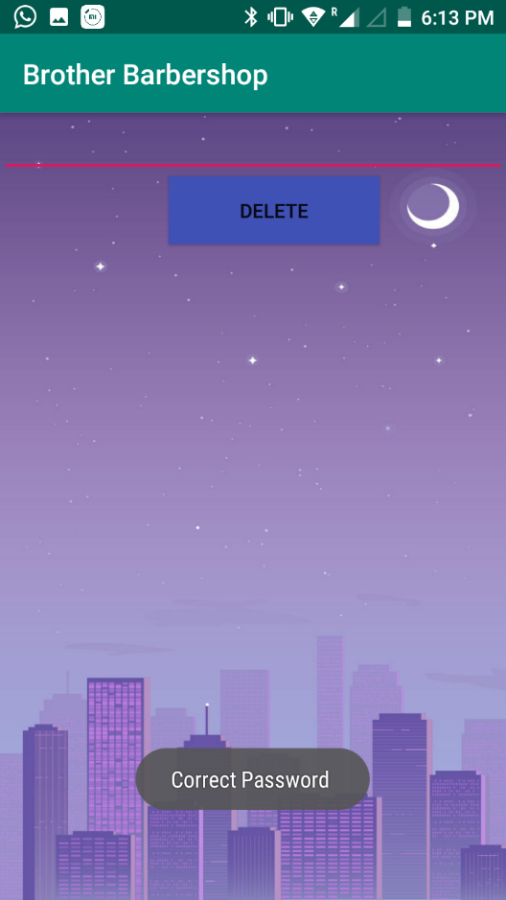

**Test Case**

|  |  |  |  |  |  |
| --- | --- | --- | --- | --- | --- |
| **Test case No.** | **Test Scenario** | **Test Data** | **Expected Result** | **Actual Result** | **Pass/Fail** |
| TC01 | In Login form, Check User name with valid data | Name:rohan@gmail.com  Password: pass | System accepts | System accepts | Pass |
| TC02 | In Login form, Check customer name with invalid data | Name = ?????? | System rejects and shows error | System rejects and shows error | Pass |
| TC03 | In Registration form, Check email id with valid data | Email id = abcd1234@gmail.com | System accepts | System accepts | Pass |
| TC04 | In Registration form, Check email with invalid data | Email id = hnjdhfb333 | System rejects and shows error | System rejects and shows error | Pass |
| TC05 | In Registration form, Check mobile number with valid data | Mobile no = 9757144637 | System accepts | System accepts | Pass |
| TC06 | In Registration form, Check mobile number with invalid data | Mobile no = 96785 | System rejects and shows error | System rejects and shows error | Pass |
| TC07 | In Registration form, Check Confirm Password with invalid data | Confirm Password=???? | System rejects and shows error | System rejects and shows error | Pass |
| TC08 | In Registration form, Check Confirm Password with valid data i.e Password | Confirm Password=Password | System rejects and shows error | System rejects and shows error | Pass |
| TC09 | In Registration form, Check Confirm Password with invalid data | Confirm Password=???? | System rejects and shows error | System rejects and shows error | Pass |
| TC010 | In Home page, Check Links by clicking on it | Null | System accepts | System accepts | Pass |
|  |  |  |  |  |  |

**Conclusion and Future Enhancements**

The system is designed keeping in mind the current requirement of the organization. However, we need do not arise all at once. They surface as per course of time. Some aspect was not considered and some new can be added in the system to cater changing user requirement.

* Admin can generate report on daily basis monthly basis and yearly basis.
* Improving efficiency of the software by making it more realistic during order processing
* Adding Payroll System to the software.

Payroll system will improve employee management activities in the software.

* Integrating with current Desktop publishing softwares so as to keep track of data about the jobs generated by employees.

**Plagiarism Report**



Plagiarism Checker X Originality Report

**Similarity Found: 0%**

Date: Friday, February 14, 2020

Statistics: 0 words Plagiarized / 1012 Total words

Remarks: No Plagiarism Detected - Your Document is Healthy.

-------------------------------------------------------------------------------------------

AndroidManifest.xml: <?xml version="1.0" encoding="utf-8"?>  
<manifest xmlns:android="http://schemas.android.com/apk/res/android"  
 package="com.example.brother_barbershop">  
 <application  
 android:allowBackup="true"  
 android:icon="@drawable/barberlogo"  
 android:label="@string/app_name"  
 android:roundIcon="@mipmap/ic_launcher_round"  
 android:supportsRtl="true"  
 android:theme="@style/AppTheme">  
 <activity android:name=".RegisterActivity"></activity>  
 <activity android:name=".MainActivity" />  
 <activity android:name=".OrdersActivity" />  
 <activity android:name=".ContactActivity" />

INTERNET SOURCES:

-------------------------------------------------------------------------------------------

**Bibliography and references**

**Website**

https://coderanch.com/

<http://stackoverflow.com/>

<https://www.tutorialspoint.com/>

<https://www.w3schools.com/>

htttps://www.youtube.com/

**Books**

## Beginning of Android by techmax publication